

**Release Information:**  
cosmOS is based on the previous work of LastOS/NightOS and from the LastOS Team. It is made using an Automated Builder with an up to date Preset.  
  
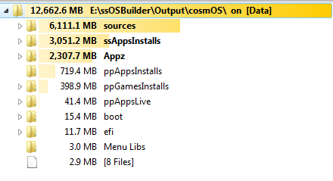  
Without the Appz folder and the ppGames Folder the ISO/USB is 9.72gb  
  
The OS's included are **x86** and **x64 Home Professional**, mostly automated (as with previous LastOS releases). The updates are up till 2012-11-01.  
  
  
**Screen shots:  
  
ssWPI:-**  
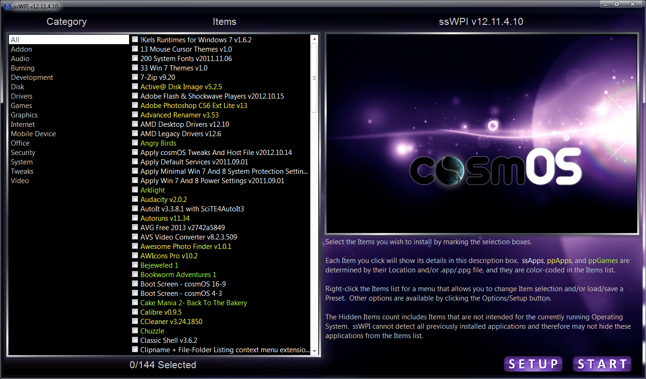

**Default Desktop & Auto Start Menu Sorting (Using SetupS Control Panel, or ssWPI Options, you are able to un-sort the start menu or sort as Kazz or LastOS style at any time):**  
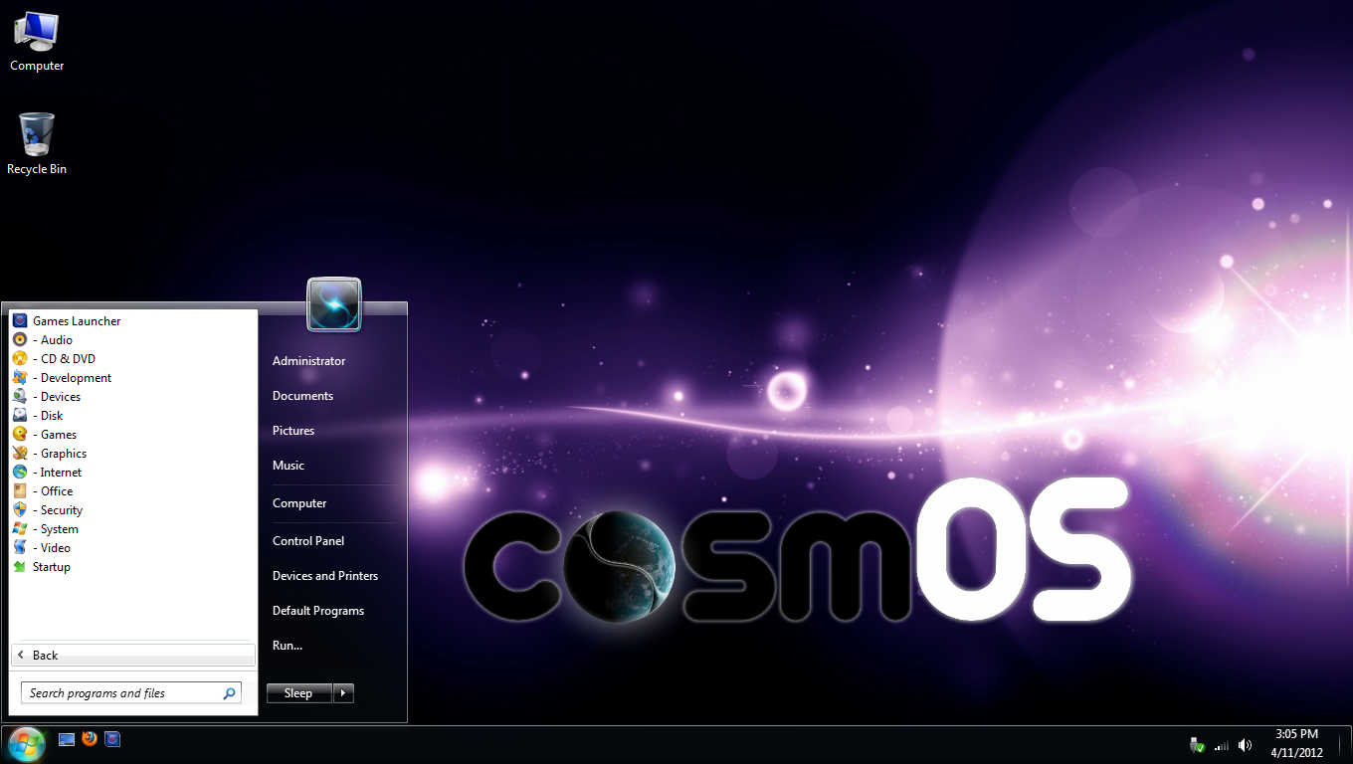

**Logon/Shutdown Screen (I kept this from NightOS), I use the same wallpaper for Windows Setup:**

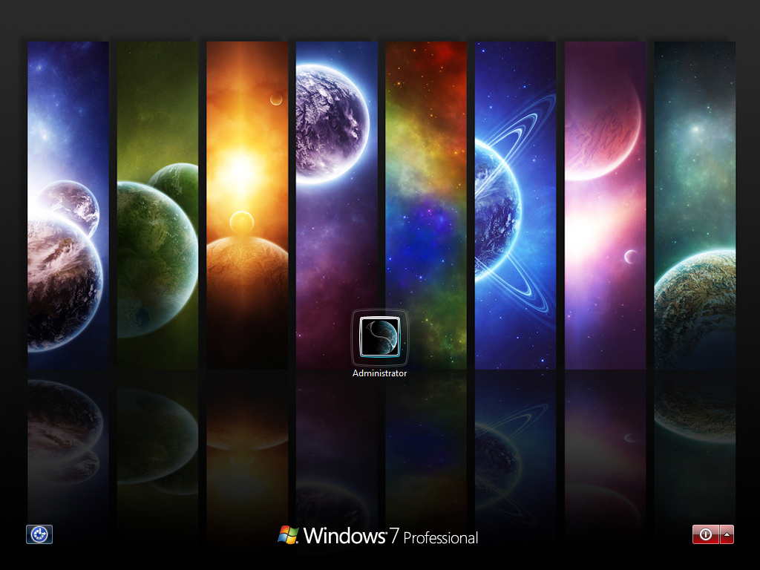  
  
  
**Autorun Menu:**  
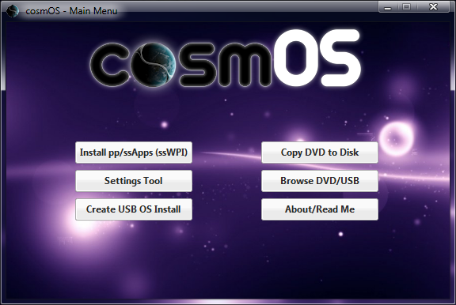  
  
**Settings Screen (Shows post install by default):**  
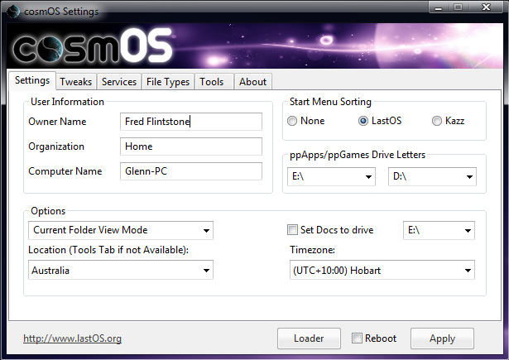  
  
**Included Apps:**  
[CODE]!Kels Runtimes for Windows 7 v1.6.2  
13 Mouse Cursor Themes v1.0  
200 System Fonts v2011.11.06  
33 Win 7 Themes v1.0  
7-Zip v9.20  
Active@ Disk Image v5.2.5  
Adobe Flash & Shockwave Players v2012.10.15  
Adobe Photoshop CS6 Ext Lite v13  
Advanced Renamer v3.53  
AMD Desktop Drivers v12.10  
AMD Legacy Drivers v12.6  
Apply cosmOS Tweaks And Host File v2012.10.14  
Apply Default Services v2011.09.01  
Apply Minimal Win 7 And 8 System Protection Settings v2011.09.01  
Apply Win 7 And 8 Power Settings v2011.09.01  
Audacity v2.0.2  
AutoIt v3.3.8.1 with SciTE4AutoIt3  
Autoruns v11.34  
AVG Free 2013 v2742a5849  
AVS Video Converter v8.2.3.509  
Awesome Photo Finder v1.0.1  
AWIcons Pro v10.2  
Boot Screen - cosmOS 16-9  
Boot Screen - cosmOS 4-3  
Calibre v0.9.5  
CCleaner v3.24.1850  
Classic Shell v3.6.2  
Clipname + File-Folder Listing context menu extensions  
CPU-Z v1.62.0  
Defraggler v2.11.560  
DirectX Runtimes 9.0c v9.29.1962  
DriveImage XML v2.44  
Driver Magician Lite v4.011  
Duplicate Photo Finder v1.1.0.148  
DVDShrink v3.2.0.15 Final  
Everything v1.2.1.371  
F.lux  
Famatech Radmin Server v3.4  
Famatech Radmin Viewer v3.4  
FastStone Image Resizer v3.1  
FileZilla v3.5.3  
Firefox v16.0.2  
Folder Size v2.8.0.0  
Foxit Reader v5.4.3.0920  
Free Commander XE v0.0.0.601  
Free Download Manager v3.9.1.1252  
Gamers Runtimes Lite v2.2  
Games Installer v12.11.4.0010  
Games Launcher v12.11.4.0010  
GIMP v2.8.2  
Google Chrome v22.0.1229.94  
Hash Tab v4.0.0.2  
ImgBurn v2.5.7.0  
IrfanView v4.33  
iTunes v10.7.0  
Java Runtime v7.0.9  
K-Lite CodeC v9.4.0 (x64)  
K-Lite Mega CodeC v9.4.0  
Libre Office v3.6.3  
Magical Jelly Bean Keyfinder v2.0.9.5  
Malwarebytes Anti-Malware Pro v1.65.1.1000  
Microsoft Security Essentials v4.1.522.0  
Microsoft Silverlight v5.1.10411.0  
Microsoft Silverlight v5.1.10411.0 (x64)  
MS .NET Framework 4 Client v2012.06.12  
MS .NET Framework 4.5 Client v2012.11.03  
MS Visual C++ Runtimes (2005, 2008, 2010) v2012.06.06  
MSXML Parser 4.0 SP3  
NanDub v1.4d  
Nero Micro v11.0.11200  
Nirsoft & Sysinternals Utilities Suite v2012.09.18  
Notepad2-mod v4.2.25-796  
nVidia Desktop Drivers v306.97  
nVidia Notebook Drivers v306.97  
Open with Arguments v1.2  
Partition Wizard Home Edition v7.6.1  
PE Explorer v1.99  
PhotoZoom Pro v4.1.4  
PicPick v3.1.8  
Plex Media Server (Portable) v0.9.609  
PleXBMC v11.2  
Portrait Professional Studio v10.9.3  
ppGames Register Games v4  
Privitize VPN 1.0.0  
Quick Launch (Remove Library Mediaplayer etc)  
Quick Launch Toolbar (1 Line Version)  
REALStudio v2012 r1  
Recuva v1.43.623  
Regshot v2.0.1.68  
Resource Hacker v3.6.0.92  
Sanitize v1.11.8.3  
SetupS SendTo Suite v8.12.11.0  
Skype v6.0.0.120  
SoftMaker Office 2012.670  
Speccy v1.18.379  
ssCleaner v8.12.11.0  
ssFATSorter v8.12.11.0  
ssWPI Installer v12.11.06.0012  
ssXFormer v8.12.11.0  
System Explorer v3.9.6  
TeraByte Image v2.7.6  
TeraCopy v2.27  
Thunderbird v16.0.2  
Tweak-SSD v1.0.4 (x64)  
UltraEdit v16.10  
UltraISO Premium Edition v9.5.3.2901  
Universal Extractor v1.6.1.64  
Universal Theme Patcher  
Unlocker v1.9.1  
Unstoppable Copier v5.2  
uTorrent v3.2.2.28379  
VirtualBox + Extension Pack v4.2.4-81684  
VirtualDub + Extras v1.9.11  
VLC Media Player v2.0.4  
VMWare ThinApp (No Pop-Up Edition) v4.7.0.519532  
VMWare Workstation Lite v9.0.0.812388  
Win7 Logon Screen Editor v1.0  
WinAmp Lite v5.6.3.3234  
Windows Live Essentials v2012.16.4.3505  
WinOFF v5.0.1.0  
WinRAR v4.20  
WYSIWYG Web Builder v8.2.0[/CODE]  
Please let me know of any essential apps you would require to be using cosmOS, I can add the ones people request.  
  
**Included Games:**  
[CODE]Angry Birds  
Arklight  
Bejeweled 1  
Bookworm Adventures 1  
Cake Mania 2- Back To The Bakery  
Chuzzle  
Feeding Frenzy 1  
Garden Defense  
Insaniquarium  
Luxor 1  
Plants Vs. Zombies Game Of The Year Edition  
Slingo Supreme  
Solitaire 2  
Super Collapse 4  
Talismania  
Tri Peaks 1 - Solitaire To Go  
Tropix 1  
Virtual Villagers 1  
Xplosive Jigsaw Pro  
Yahtzee GH  
Zombie Bowl-O-Rama  
Zuma 1[/CODE]  
I have included some games in this release to enable OS installers to have a few with them, just in case they are stuck waiting for something to complete, if you can recommend any you want included then make sure it's reasonably sized (100mb or less) and/or if you think I should remove any from the default release.  
  
**Other information:**  
  
The default context menu's have been created by Trouba to offer the very best look and a way to get to the most use tools  
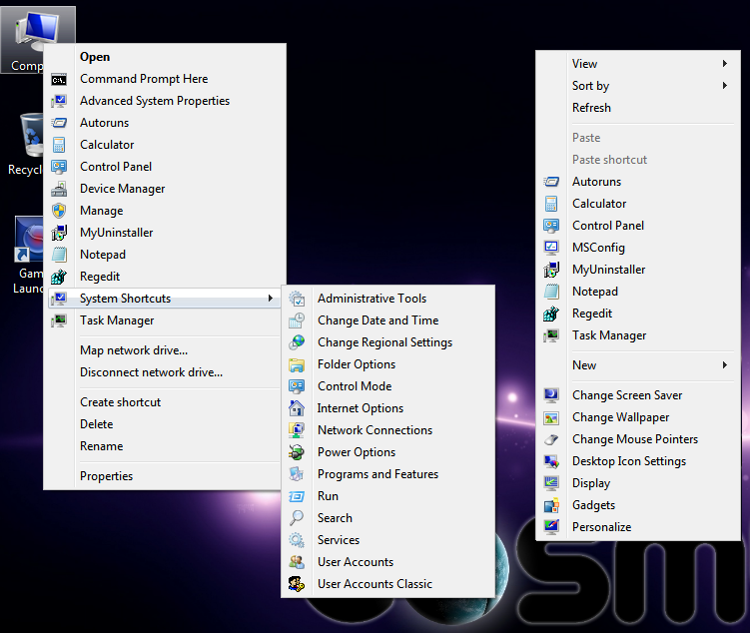  
The context menu on the left is the Computers one and the one on the right is the Desktops menu.  
  
**New Driverpack method (space/time saved):**

Ghost had come up with a way to use the Driverpacks but to remove any unused ones from the completed OS install, the space saved is many GB's, this is quite important on SSD's and it also speeds up how quickly new hardware installs, including when you plugin USB devices for the first time:  
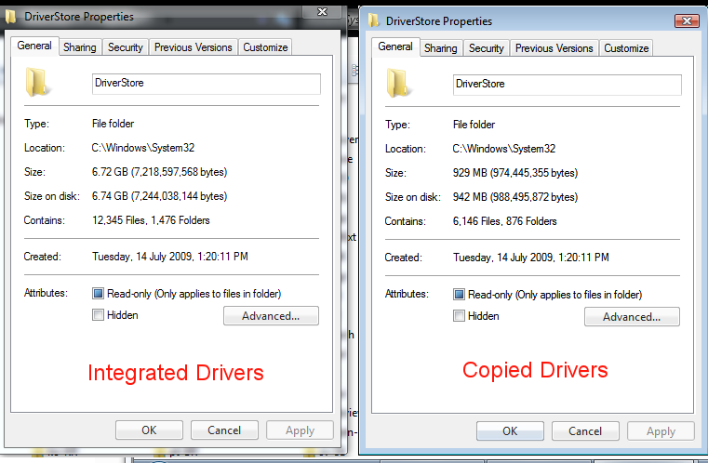  
I have also separated out the larger ATI/AMD and nVidia drivers into silent installs available from ssWPI, that way your not going to have conflicting versions or more space taken up on the computer.  
  
**You have an optional matching boot screen available from ssWPI:**  
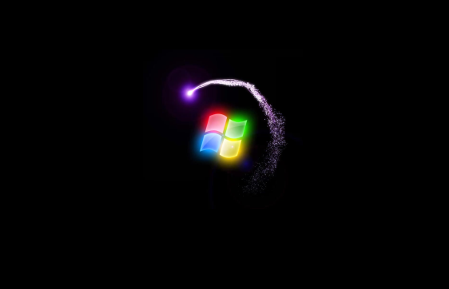  
**I removed all text, so your just left with an animated logo.  
  
My own personal Build has an extra Appz folder on the ISO/USB containing:**

Corel PaintShop Pro X4 (sp2)  
Office 2010 & SP1  
absinthe-win-2.0.4.zip  
AdobeAIRInstaller_3-5_win.exe  
Development.Tools_v2012-10-06.exe  
FreeRAM.zip  
gimagex.zip  
ifunbox_setup-1.99.exe  
IntelHD3000Silent.exe  
Kies_2.5.0.12094_28_8.exe  
ProcessExplorer.zip  
redsn0w_win_0.9.15b2.zip  
  
The office 2010 is up to date until 2012.10.26 and is only 1.64gb (x86 only as works on all OS's), it uses AutoKMS to activate. I could make this silent but it's much more useful to select your own components.  
  
The LivePE shown below has all the tools needed to backup, recover, configure and install your PC's, the DVD/USB will boot to this screen by default, you then backup, partition, select apps from ssWPI and start the install of the Arch your after (if offers x86 and x64), once you configure the Setup the rest is Automated until the Settings Screen at the end of the install, you must let ssWPI complete before you apply your settings or some of the tweaks may get reverted by installing apps. The LivePE is also installable from the Tools tab of the Settings app, this lets you boot to the LivePE straight off the HDD, it loads in to ram, so your able to image and restore your C:\ without anything being locked/unavailable, I have included TeraByte Image for Windows for doing images, Partition Wizard for partitioning, Opera for browsing the internet and Startup Repair for repairing your Windows 7 OS directly from the LivePE.  
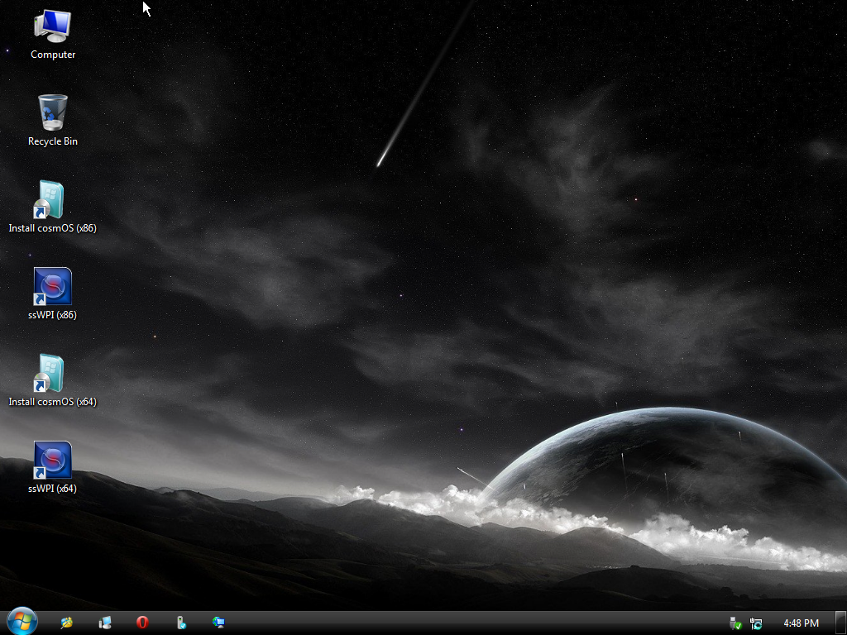  
  
There is only one manual step at the end of your installation I recommend you do, go to C:\Users\Administrator folder, right click Downloads folder and choose properties, then under the Location Tab move it to your 2nd partition/drive, that way you can image and restore your PC without losing your download folder, this can not be automated like the other documents folders as it breaks the quick link in the explorer windows (above library/trees).  
  
Google Chrome is the only app that self runs itself during setup, just close out of it, or log in to your account so it syncs your data from the cloud.  
  
Due to my hatred of automatically rebooting your PC, I have not done this and you will be required to do this manually before some tools will work.  
  
Here is the x86 Freshly installed: The total size of the install is 7.3gb + the pagefile (remember this OS is up to date)  
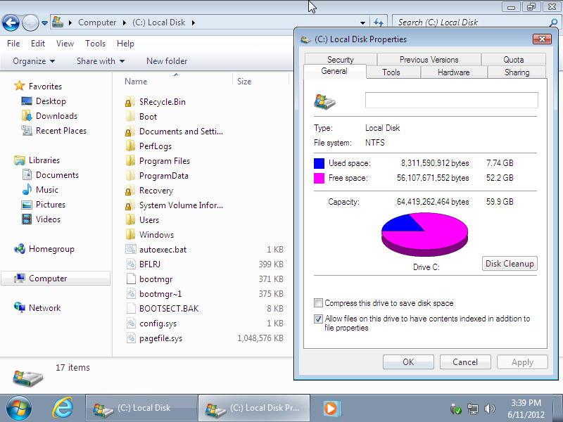  
  
Here is the x64 Freshly installed: The total size of the install is 10.2gb + the hibernation & pagefile (remember this OS is up to date)  
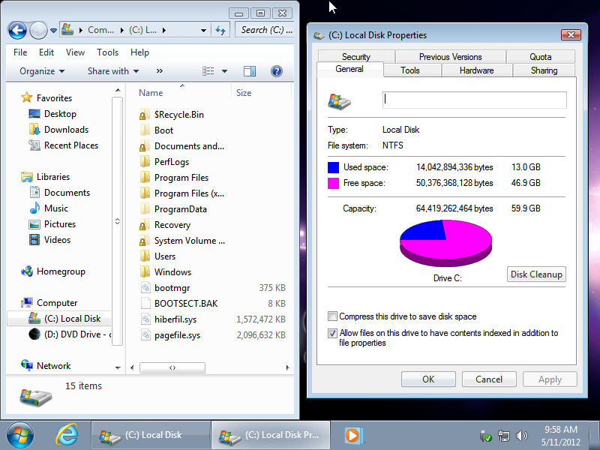  
  
  
Here is a screenshot of the ssOSBuilder with cosmOS Preset loaded:  
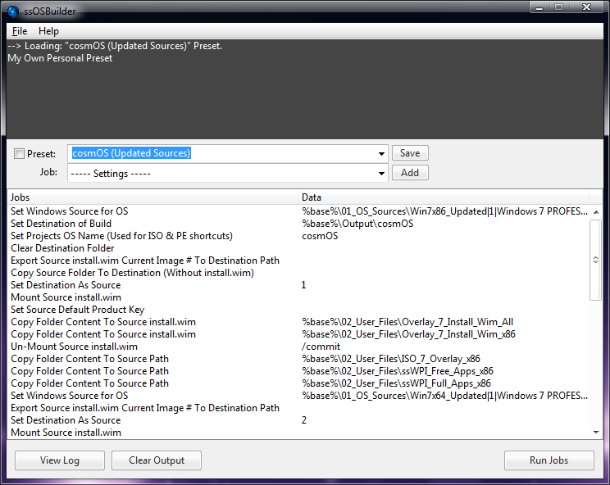  
Pressing run on this will use the pre updated source (a preset you load does this first so you can re use the updated sources) to make the OS mod, it works by overlaying wim and ISO information from specified folders.  
  
**Download Builder:**  
[ssOSBuilder v12.11.02.12 (cosmOS based) | LastOS](http://www.lastos.org/forum/index.php?threads/ssosbuilder-v12-11-02-12-cosmos-based.796/)  
****  
The Daz Loader is no in the 'X:\sources\$FirstLogonApps\DazLoader.exe" by default, you can easily remove this from your USB or ISO drive if you don't want this.  
  
* I've updated the ssWPI available to install to be able to use the online repository of apps, by default I have this disable on the version included on the DVD/USB so that you only have access to the essential apps and are not overwhelmed with options. the installable ssWPI will create a desktop shortcut and be in the root of the start menu.  
  
* Even tho I include partition tools in the LivePE, make sure to use the Windows format to erase the boot drive/system drive, I have had VM's fail to boot when I make a fresh HDD image and only format with Partition Wizard. It's nearly instant to use the Windows format during setup, this makes sure it's right and set to active. So if your PC stops on the first reboot it may be the HDD format's fault.  
  
*If you always install the same apps from ssWPI and don't want to run it and set the menu sorting type each time:  
Go to X:\sources\$ssWPI\Presets <-on USB or DVD or drag changed files into your ISO:  
  
AutoInstall_x64-Disabled.ini  
AutoInstall_x86-Disabled.ini  
AutoMenu_x64-Disabled.ini  
AutoMenu_x86-Disabled.ini  
  
just remove the -Disabled bit and they will be re-activated to set what is contained in them, you can save your own preset and set the name of it to AutoInstall_x64.ini or AutoInstall_x86.ini, then put the menu style in AutoMenu_x86.ini or the x64 one. Doing this will enable you to simply pick Install cosmOS from the LivePE without running ssWPI first and still have your prefered apps installed... so for really lazy people :P  
  
**\* Keep in Mind:-**  
I have removed the nVidia/ATI/AMD Graphics drivers from the driverpacks, they are now offered in ssWPI, you can install them at any time. I did this because having 3gb of nVidia drivers on a AMD system is pointless, and having both AMD and nVidia on an Intel GFX Ultrabook is also pointless and a waste of SSD space/life.

**How to Install**

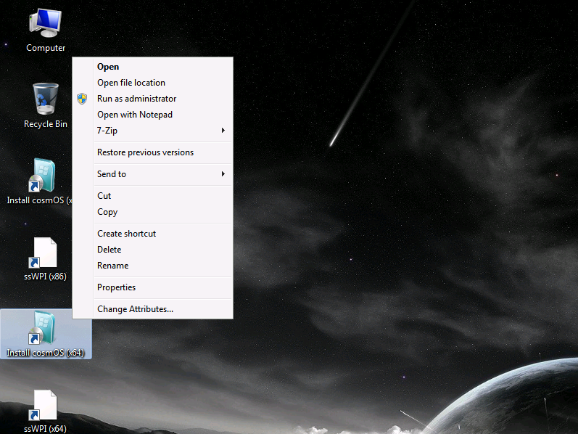

1. Mount the ISO with UltraISO  
2. Create a USB Disk using Make USB from the ISO Menu (if you haven't already got a bootable USB  
3. Copy the content off the mounted ISO to the USB (if it fails to copy with the script)  
4. Reboot the PC and use the Function key on your keyboard to invoke the boot device menu, picking the USB device  
5. Double Click Install cosmOS  
6. Say WOW!!!

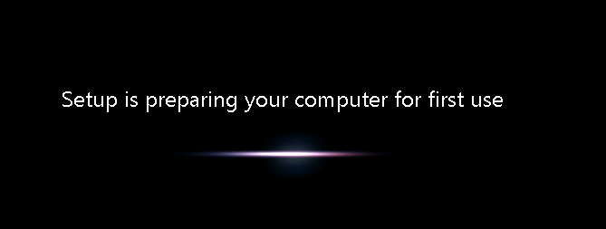

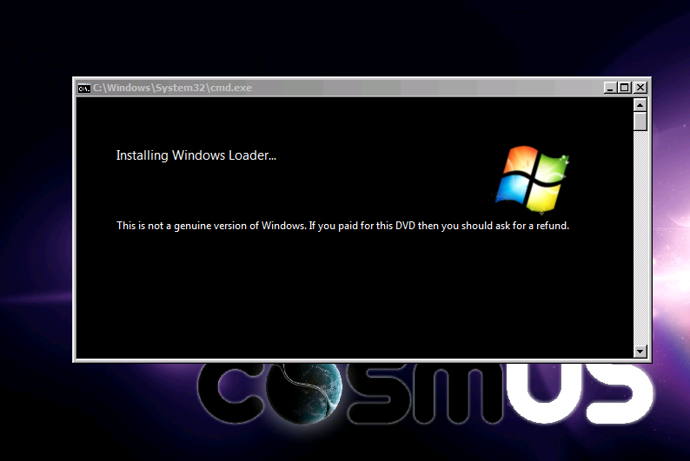

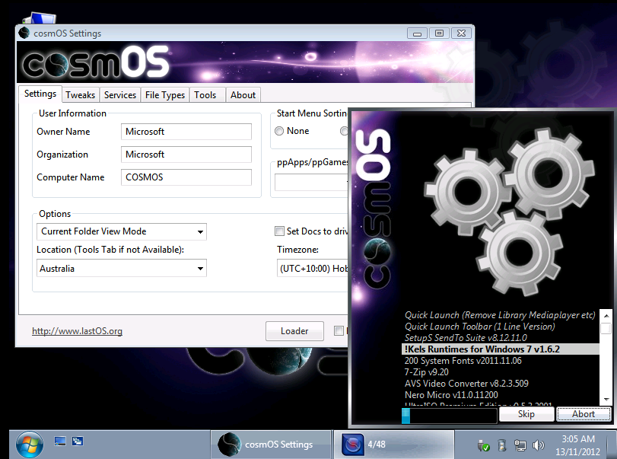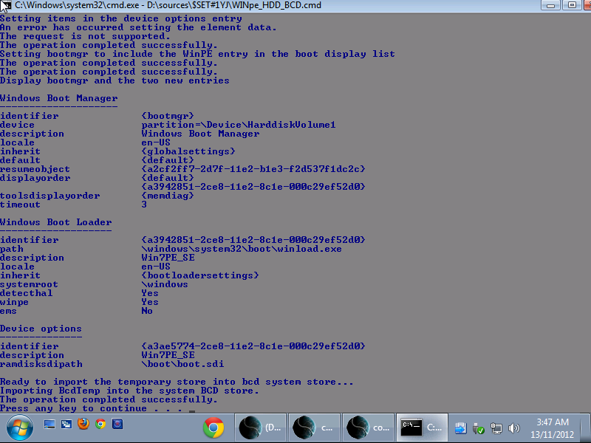

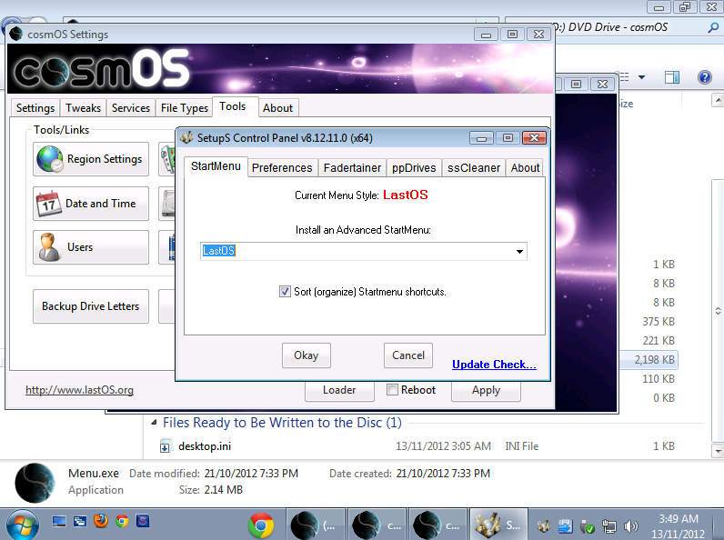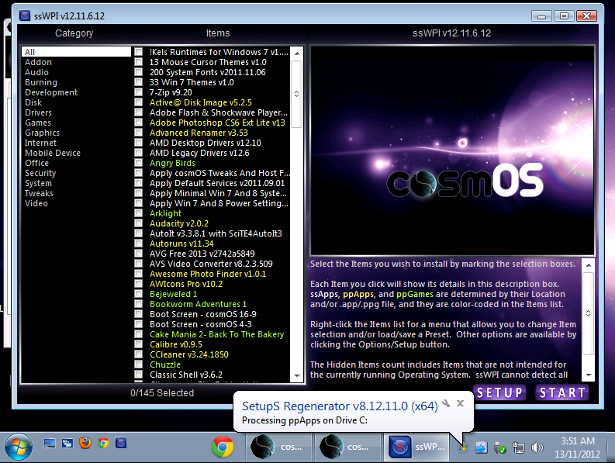

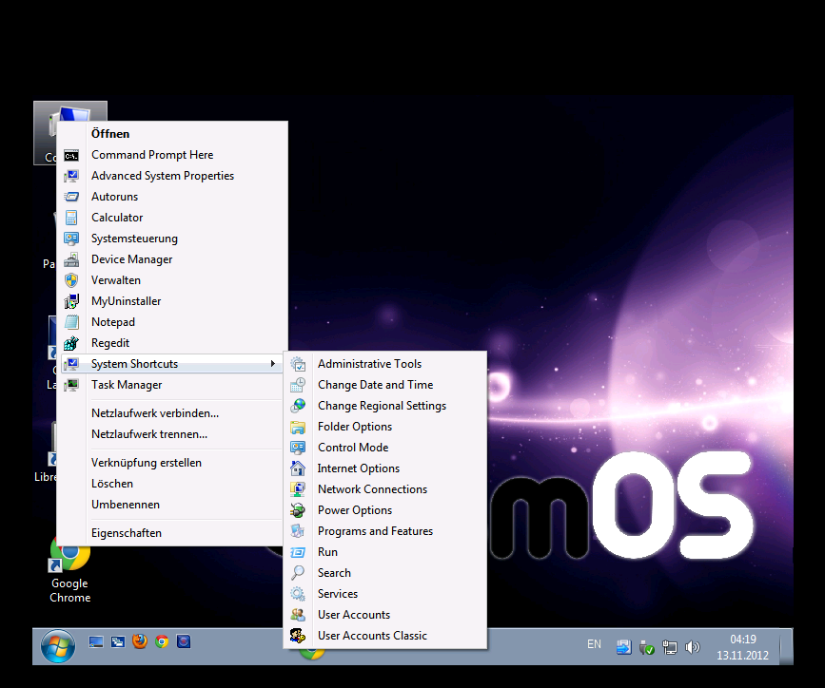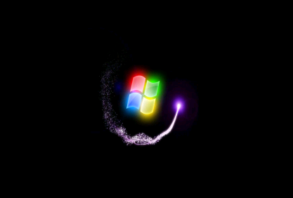  
  
**File Name:** cosmOS.iso

**Source:** Windows 7 SP1 Build 7601 x86 – x64  
**Size:** 10,3 GB (11.082.313.728 Bytes)

**CRC32:** 5F8E4D0B

**MD5:** 0F6C2BCC472A9D30658A9CD413F07541

**SHA-1:** AAA72BFA3C50E30F461A900999EBAAAE00B1D5E0

**Language:** Default en_Us

**Additional Language:** Windowsupdate